Financial Market Integration in Euro Area
Development and obstacles

Zhang Jikang, Wang Xinhui
Center for European Studies, Fudan University

Financial market integration is a process leading to the removal of the relevant frictions and obstacles. In this sense, a market for a given set of financial instruments or services is fully integrated if all potential market participants bearing the same relevant characteristics such as facing a single set of rules when they decide to deal with those instruments and services, having equal access to the above mentioned set of instruments or services, and being treated equally when they are active in the market. This process in Euro area began and proceeded with prevalent concern from the whole world because it is the initial trial over such a wide area and among a dozen of countries. The progress in every stage of the convergence offered valuable experiences and referenced example for the rest of the world.

Financial market integration in Europe has launched long before the issue of Euro and has proceeded slowly but steadily. From the founding of Economic and Monetary Union (EMU) in 1969 to the established aim of removal of capital controls in1991 it came the most historical step to start the single currency in January 1999. With all the theoretical and empirical evidences, the issue of Euro undoubtedly offered a strong motivation for the procedure because a single currency is an important component of a common financial system and a strong promoter of financial integration. But that is not enough. The 42 legislative measures committed in the Financial Services Action Plan (FSAP), which should be fulfilled no later than 2004, strived to ensure three objectives. That is a single EU market for wholesale financial services; open and secure retail markets and state-of the-art prudential rules and supervision. The fulfillment of the FSAP will offer an strong guarantee of the ultimate goal of a “Core Europe” which is a strong and integrated economic and political union. Due to that financial market integration in Euro area has become the hot focus in the academic field of finance and economy in the whole world.

In the article, I would like to mainly take stock of what the current situation is.

State of play: progress of financial market integration in Euro area can be reflected in the following aspects

The introduction of the euro now five years ago has undoubtedly led to larger, deeper and more integrated financial markets. This has been especially the case in wholesale markets, such as the unsecured money market, the government bond market and the related derivatives markets. Wholesale markets, such as the unsecured money market, the government bond market and the related derivatives markets. Progress also occurred, although at less impressive rates, in the corporate bond and equity markets. However, not all wholesale markets are equally fully integrated, the repo market being a particularly special case. Generally speaking the transaction scale and type of products in fund trading market increased greatly, which can be showed respectively in money markets, bond markets, equity markets, related payments, clearing and settlement infrastructures

1. Money market

The integration of the European money markets relies, of course, on the existence of a single system for refinancing the banks in the euro area, that is to say on the common monetary policy. However, it also relies technically on a system of instantaneous data transfer and on the new common payment system, TARGET, enabling real-time gross settlement. Thanks to the smooth operation of the information, communication and payment systems, a common monetary policy is realistic and the integration of the markets can take place. Such integration will, in turn, involve greater liquidity and further development of the financial markets.

A specific channel through which the monetary policy of the ECB and the TARGET system can have a direct impact on the development of the financial markets of the euro area is the requirement to have guarantees or collateral for operations with the ECB. This requirement for adequate collateral can stimulate the process of loan, especially in the case of the banking institutions of certain financial systems. The underlying assets can be used across borders, which means that a banking institution in a country belonging to the European System of Central Banks (ESCB) can receive funds from its national central bank by pledging assets located in other countries, which is also relevant from the perspective of the integration of the financial markets of the area.

The considerable growth of interest rate instruments resulted from a strong increase in swaps and forward rate agreements (FRAs). Transactions in euro have been forstered by the creation of a large, liquid and integrated money market in the euro area. For example, swap and FRA transactions increased by 104% and 85%, respectively, between April 1998 and April 2001.

The unsecured and swap segments have for some time now been showing a high degree of integration and the BIS survey confirms that the growth in the swap market has been particularly significant. The EONIA reference interest rate has established itself as one of the most important, or even the most important, reference rate. The EONIA swap market is now considered the largest overnight swap market in the world. The market for short-term securities and the repo market, by contrast, still remain poorly integrated: even if both markets have taken some steps towards integration, clear fragmentation among the euro area countries remains.Which will be discussed in more details in the latter part.

The money markets of the euro area became rapidly integrated after the introduction of the euro, which can be showed clearly in the following table 1.

Table 1 Money Market Financing in Euro Share More Than Doubled
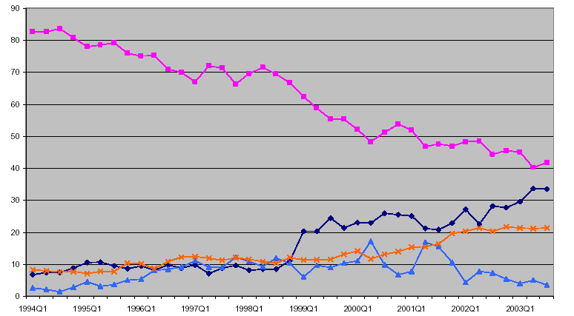
Source: BIS, ECB staff calculations

As shown in the table, transaction volumes in euro share leaping greatly indicate that the markets reached a very high level of liquidity. And this trend is expected to continue.

In response to the introduction of the euro and the new monetary policy framework, the euro area money market underwent a wide-ranging process of integration and standardization in 1999. As a result, the unsecured deposit market and the derivatives markets have already been fully integrated. For other segments of the euro area money market, such as the repurchase agreement (repo) market and the short-term securities markets (for Treasury bills, commercial paper or “CP”, and certificates of deposit or “CDs”), the integration process will continue in future.

2. the Euro-denominated Bond Market.

The euro-denominated bond market is today much more homogeneous than in 1999. It is well integrated, deep and liquid, and provides a wide choice of investments and funding. There was a marked rise in private bond issuance in the euro area in 1999, which has continued broadly unabated up to date. These changes show that the newly created euro-denominated bond market, by virtue of its size and high degree of openness, is more able to absorb very large issues than the individual bond markets of the predecessor currencies of the euro. Since the creation of the euro, bond market investors have no longer been concerned by intra-euro area exchange rate risks. As a result of lower foreign exchange risk and an environment of low inflationary expectations, credit risk has gained more importance, in relative terms, in the pricing of financial instruments.

Financial market participants active in the euro area have stepped up their assessment of the credit quality of securities issuers. The private segments of the euro area bond market have prospered since the introduction of the euro, in particular the corporate bond market, although they started from a low level. An increase in liquidity is reflected in large private issues of above 1 billion Euro.

3.Equity market and stock market:

While there is ample evidence that full convergence in European bond markets and money markets had been achieved, it is far less clear whether, and to what extent, European equity markets have become more integrated. A traditional feature of the financial system of continental Europe has been a marked dependency on the funds intermediated by banks. This feature contrasts with the financial system of the United States, which is much more securitised. For instance, corporate bonds have not been very widely issued in the euro area, and stock market capitalization relative to the size of the economy is much lower in the euro area than in the United States.

With regard to equity markets, the weight of euro area stock exchanges in terms of capitalization ranks a clear second, far behind the United States. But still by most measures, euro stock markets have registered record growth in recent years. And the Euro area market has taken over from the US the role as the most important market in explaining equity returns in most individual European markets. While their size is still substantially smaller than that of the US stock market, both in absolute terms and as a ratio of gross domestic product (GDP), new issuance activity was higher in relative terms. Privatizations and M&A activity have had an important bearing on the supply of euro area equity products, and more generally, European equity products.

After the issue of Euro, the single currency also appears to be a catalyst for restructuring the European corporate sector, and for the emergence of new companies. Primary issues of European equities have reached record highs, with whole new markets, such as the Neuer Markt in Frankfurt, becoming prominent internationally. In addition, a number of Europe-wide equity indices have been established, thereby contributing to extending the trading possibilities and the position-taking opportunities for investors. Alliances between stock exchanges should also foster the integration of stock market infrastructures.

As shown in Table 2. A GARCH methodology with time-varying coefficients is used to analyze the integration process of European equity markets since the 1980s. Rolling estimation and recursive estimation techniques are used to illustrating time-varying financial integration. It shows the coefficient estimates not for an individual country but the coefficient average for the Euro area countries, with each country being weighted by its GDP share in the Euro area.

From the figures we can draw the results that European equity markets have become highly integrated only since 1996. Also the Euro area market has gained considerably in importance in world financial markets and has taken over from the US as the dominant market in Europe.

Table 2 Time-Varying Integration Euro Area Average GARCH 12-Month Rolling Estimates

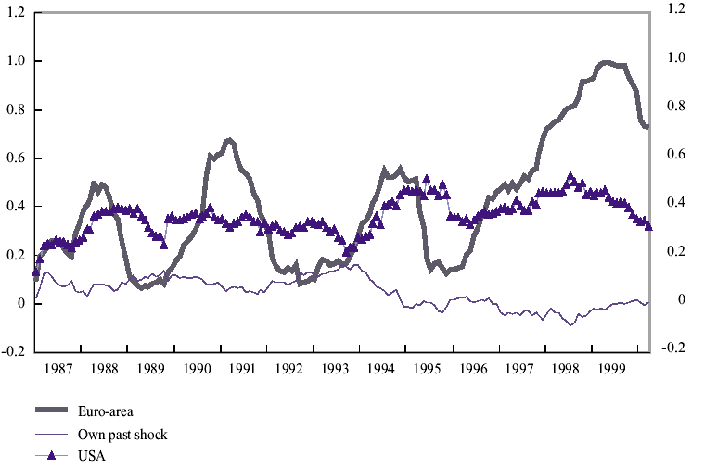
Source:

The pace of financial innovation has been set by investor demand for equity exposure as well as by a high degree of corporate restructuring. Starting from this situation, many commentators have correctly observed that the euro area is currently engaged in a process of structural change towards more market-based finance. As Alan Greenspan put it, recent "changes appear to be moving continental Europe's financial system closer to the structure evident in Great Britain and the United States".

4. Related payments, clearing and settlement infrastructures

More and more financial market players entered and expanded the financial institution markets such as the banking industry, the insurance industry, corporations and funds. In a much wider scope, corporations, financial market players and European Central Bank (ECB) all have a common interest here. So mature and complete trading platform is undoubtedly a necessary precondition. Related payments, clearing and settlement infrastructures whose rapid progress was the requirement of further market integration also fostered the process.

TARGET, the new area-wide payment system which constitutes the major settlement system for payments in euro, has played a key role in facilitating the redistribution of liquidity across the euro area. In addition, by encouraging greater arbitrage activity, TARGET has facilitated an equalisation of prices prevailing in the various segments of the money market throughout the euro area.

Especially, the launch of Euro efficiently reduced the dealing cost and risk, and thus improves the transaction efficiency due to the simplification of dealing currency.

A more general and clear reflection about the developments in euro area payment and settlement systems can be seen from the following table 3. Though merger and consolidation, the decrease of payment, settlement and clearing institutions simplified the transaction procedure, reduced the dealing cost and accordingly increase the return on investments. From the figures compared with US, the whole euro financial market strided for a united and mature single market.

Table 3 Number of Settlement System Comparison and Trend
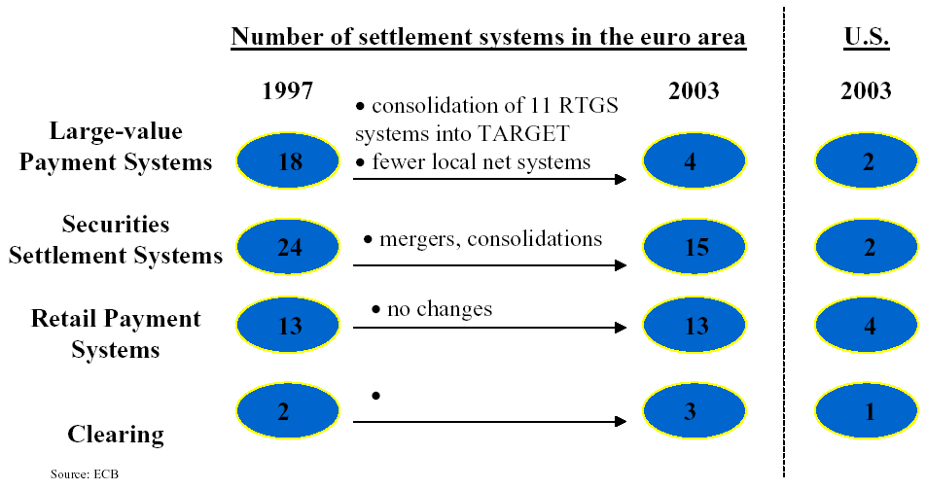

Financial market integration can also be reflected from the comovement of the investment return and time-varying coefficients

The more integrated markets are, the higher the comovement between their prices, that is the return of investment in different markets. With perfect cross-market integration there are no cross-market arbitrage opportunities and the law of one price which means portfolios with the same payoffs should have the same price in different markets holds.

The efficiency of return of stock market offers a good example to analyze the degree and nature of integration in European equity markets. It offers empirical evidence that the European unification process has raised the degree of integration, in particular among countries that have adopted the Euro. Overall, the results of the paper also indicate that the Euro area equity market has gained in importance in world financial markets since the mid-1990s, although the degree of financial integration has been highly volatile over the years.

As to the time-varying coefficients, we can still use table 2 in the security market to illustrate the exchange rate volatility in the integration of stock markets. Despite the volatility in integration, the results show that the Euro area has become the dominant market for most individual Euro area markets since the mid-1990s. The US market was the most important one for all individual European markets till the mid-1990s, but while its impact has remained roughly constant in the long run, the effect of Euro area shocks on individual markets has often more than doubled between the early and late 1990s.

And the striking feature of the rolling estimations is the high degree of volatility of integration within the Euro area. The dynamics of integration for most Euro area markets show the same behavior: a low degree of integration during 1992-93 and 1995, a very rapid increase between 1996-99 and then a leveling off or even slight decrease in 1999-2000.

Still some obstacles hampered the further integration of the financial market in Euro area. There is still a long way to go before the benefits can be showed fully.

With all the progress in the course of financial market integration, there still leaves a long way to go before all the gians of integration can be got. They are obstacles in both market layer and some political obstacles. It is clear that we need, in particular, to intensify our efforts to support internal financial market integration in the euro area. Very many initiatives and activities are involved in the process. Lower transaction cost, decreased home bias, dealing preference, growth prospect and expected return are all obstacles that can not be omitted.

The FSAP is the Community’s central tool for attaining deeper integration in the financial sector. Progress in integration of financial markets in the euro area has been slow, especially in the retail markets. However, more than three quarters of the FSAP measures have been completed since the inception of the plan in 1998. It is important to adhere to the timetable for implementing all the proposals in the FSAP by 2005, which were deemed necessary already in 1998. April 2004 is set as the final date for adoption by the council of all measures – to allow 18 months for transposition in the member states after that. More particularly common financial markets in the euro area have matured in the areas where the infrastructure is simpler as in the wholesale business or where the public sector is most involved. By contrast, in areas where EU-wide public infrastructure is scant, markets remain regional and transaction costs for cross-border activity remain high. While the markets generate solutions around existing barriers they are often far from optimal from an economic efficiency point of view and costly. The authorities should focus on removing such barriers. Continued efforts on cross-border clearing and settlement arrangements following the Giovannini group’s work (Giovannini, 2003) are an example. Looking beyond the FSAP, however, this framework should be supplemented by a wider set of reforms.

The current structure of regulation and supervision is the result of different administrative, legal and financial approaches across countries. The focus should be on legal and regulatory reforms that protect the rights of investors and enforces contracts, and thus supports the functioning of both markets and intermediaries. Admitting the slow process of adopting legislation, the authorities have taken steps to re-shape the regulatory process by separating first principles from secondary legislation. The new framework, based on the Lamfalussy proposals, has recently started working in the securities markets. The introduction of similar committee structures covering insurance and banking was a long overdue step. However, these committees, consisting of members with strong national interest, must be kept transparent and use consultation processes continuously.

Conclusion: From all the analysis in the article, the financial integration in Euro area has gained much progress. The trend of further convergence can be taken for grated and is also the requirement for the development and maturity in the Euro financial market, even the whole world. Steps from ECB and EMU should be taken to further hence the process.

Bibliography:
- Carl Gjersem (2003) “Financial market intergration in the Euro area”, OECD department working paper No.368
2. Vítor Gaspar(2004) “Financial integration and the international role of the euro” ECB panel remarks
3. MARCEL FRATZSCHER(2001) “Financial market integration in Europe: on the effects of EMU on stock markets” ECB working paper NO. 48
4. Mr Jean-Claude Trichet, President of the European Central Bank(2004) “The integration of European financial markets”, speech at the Deutsche Börse’s New Year’s Reception 2004, Frankfurt am Main
5. Dr. Willem F. Duisenberg, President of the European Central Bank(1999), “ Developments in the financial sector in Europe following the introduction of the Euro” Speech delivered at the Third European Financial Markets Convention
6. “ The Euro and the integration of financial services” article published by ECB (2001)

Contacting address
Zhang Jikang
Center for European Studies
Fudan University
No. 220, Handan Road, Shanghai
200433 P. R. China
Tel: 021-65642668
Fax: 021-65646456
Email: jkzhang@fudan.edu.cn

